Our Privacy Statement
20 December 2021

Smart Visie

This is the privacy statement of the company J.C.A. Scheer trades under the name Smart Visie (hereinafter: Smart Visie) is registered with the Chamber of Commerce under number 27364759 and is located at Tobias Asserlaan 7 (2662SB) in Bergschenhoek.

This document explains how Smart Visie handles the processing of your personal data. Smart Visie takes the greatest possible care when processing your personal data.

Obtaining personal data:
If you use the services of Smart Visie, you provide a number of personal data to Smart Visie yourself, or personal data will be obtained from you in the context of the agreement. Personal data is understood to mean all data relating to an identified or identifiable natural person.

Categories of personal data
Smart Visie processes the following categories of personal data:
- Contact and name and address details;
- Location data, such as postal codes with house numbers;
- E-mail address;
- Financial data;
- Account information, including your password and username;
- Order history;
- Company details;
- Different delivery address;
- Other personal data provided by you.

Purpose of the processing
The personal data processed by Smart Visie aim to:
- Contact you to inform you about the services you have purchased and the implementation thereof;
- Performing its services;
- Improve services;
- Making payments;
- Compliance with legal obligations;
- Doing marketing and communication expressions;
- Improve the website by analysing visitor behaviour on the website;
- Sending newsletters;
- Data exchange with third parties for the performance of the services.

Basis for processing
The processing of personal data is only possible on the basis of the following principles: (i) legal obligation, (ii) performance of the agreement, (iii) obtained (explicit) consent from the data subjects, and (iv) legitimate interest. Personal data is processed when providing the services of Smart Visie. Smart Visie only processes data that Smart Visie deems necessary for (improving) the services and handles the (personal) data it has collected about you and your use of the services with due care. The basis for processing this data is the agreement you have entered into with Smart Visie. Personal data about you may also be processed by visiting the website www.smart-visie.nl if you have given permission for this.

Need for processing
The processing of your personal data is necessary to be able to provide the services. The services offered by Smart Visie cannot be fully performed without processing your personal data. If your explicit permission is required for specific purposes with regard to the personal data, you must give separate permission for this.

Automated decision-making
There is no automated decision-making.

Retention period
The personal data processed by Smart Visie is stored in accordance with the relevant laws and regulations. If a longer retention period is necessary on the basis of legislation or regulations, the personal data will be stored longer in accordance with these requirements. All (obtained) personal data is not kept longer than strictly necessary.

Processing by third parties
Smart Visie only shares personal data with third parties if this is strictly necessary for the execution of an agreement and to comply with relevant laws and regulations. No personal data is sold. Smart Visie may have a legal obligation to share personal data with third parties. If personal data is shared with third parties, processing agreements are concluded for this. The third parties with whom personal data are shared are:
- The delivery service(s) engaged for the purpose of executing the agreement. The categories of personal data that are processed are contact and name and address data and location data.
- The Payment Provider, for the purpose of executing an agreement. The categories of personal data that are processed are financial data.
- The Bookkeeper, for the performance of an agreement. The categories of personal data that are processed are contact and name and address data and financial data.
- Software suppliers, for the implementation of the agreement. The categories of personal data that are processed are the location data, the e-mail address and contact and name and address data.
- Website operator, for the purpose of executing the agreement. The categories of personal data that are processed are the location data, the e-mail address and contact and name and address data.
- Third parties engaged for the purpose of executing the agreement. The categories of personal data that are processed are the contact and name and address details.

Security of Personal Information
Smart Visie takes the protection of your personal data seriously and takes this into account, taking into account the state of the art, implementation costs, as well as the nature, scope, context and processing purposes and the risks to the rights and freedoms of individuals varying in likelihood and severity, appropriate technical and organizational measures to ensure a level of security appropriate to the risk.

Disclaimer
By using the website you agree to the disclaimer. Smart Visie reserves the right to change the content of its website and / or this disclaimer at any time without informing its customers and / or users of the website about this change. The content of the website has been compiled with the greatest possible care, but may nevertheless contain possible inaccuracies or be incomplete. Smart Visie does not accept any liability whatsoever for damage caused by or resulting from the use of the website. The use of this website is entirely at the expense and risk of a user of the website. No rights can be derived from the content of the website. All texts on the website are protected by copyright and the property of Smart Visie insofar as they do not belong to third parties.

Cookie statement
Smart Visie uses technical and functional cookies to optimize the website. Cookies are small text files that are sent with the visit to a website to make user experiences of visitors more efficient. Smart Visie may, by law, store cookies on your device if these cookies are strictly necessary to use the website. Your consent is required for other types of cookies. We recommend that you accept cookies in connection with the user-friendliness of the website. Visitors to the website have a check-in option.

The cookies that Smart Visie uses are functional cookies: these cookies ensure that the website works properly. These cookies have no consequences for privacy, so that permission does not have to be requested and granted. With these cookies, for example, your browser settings are stored so that our website can be viewed best, or that the website remains accessible (load balancing), but also cookies that ensure that no other cookies may be placed (no-follow).

With your permission we place ''tracking cookies'' on your computer. We use these cookies to keep track of which pages you visit, in order to build a profile of your online behaviour. This profile is not linked to your name, address, e-mail address and the like, but only to tailor advertisements to your profile so that they are as relevant to you as possible.
Google's cookies are also placed on the Smart Visie website for the purpose of Google Analytics. We do not keep any information about what you do on the internet. Google Analytics may be required by applicable laws and regulations to provide access to this data. This means that Smart Visie cannot link information to a natural person. If you have any questions about this, please contact us via contact@smart-visie.nl.

Use social media
Smart Visie uses cookies from third parties to optimize the website. Some cookies are placed by third party services that are displayed on the website. By third parties is meant Google Analytics and social media (LinkedIn, Facebook, Twitter, Instagram). The privacy and cookie policy of the relevant company applies to the use of cookies from other companies (third parties). When you click the social media button on the website, a social media cookie is placed. This allows the social media party to recognize your IP address as soon as you share an article from the website. For the cookies of social media parties and the data and / or personal data they collect with this, Smart Visie refers you to the privacy and cookie statements of these parties.

Newsletters and other marketing emails
You can register via the website for a newsletter and/or for commercial offers. When you register, Smart Visie asks you for permission to process your email address for the purpose of sending you marketing emails containing the latest information about products and services, special offers and marketing campaigns. You will only receive marketing emails if you have given your consent.

Your consent also includes that Smart Visie may personalize the content of marketing emails in accordance with your needs and interests based on any user profile created for you.
Your consent to the sending of marketing emails can be withdrawn by you at any time by clicking “Unsubscribe” at the end of the marketing email. Withdrawing consent does not affect the lawfulness of processing carried out prior to the withdrawal of consent.

Browser settings
If you do not want websites to place cookies on your device with which you view the website, you can adjust your browser settings. Before a cookie is placed, you will receive a warning and you must give permission for the cookie. Failure to do so may result in the website functioning less well, for example. You can adjust the settings of your browser so that your browser refuses all cookies and also cookies from third parties. You can also delete placed cookies. To do this, you must adjust your browser settings via preferences and then you can adjust the privacy settings.
This privacy statement does not apply to websites of third parties that are connected to this website by means of links. We cannot guarantee that these third parties will handle your personal data in a reliable or secure manner. We recommend that you read the privacy statement of these websites before using these websites.

Right of data subjects
As a data subject, you have the following rights:
- Right of access;
As a data subject, you have the right to obtain information about whether or not your personal data is being processed and, if that is the case, to obtain access to the processing thereof.
- Right to rectification;
You have the right to obtain rectification and addition of incorrect data.
- Right to erasure;
Without unreasonable delay, a data subject must obtain erasure of personal data concerning him.
- Right to restriction of processing;
As a data subject, you have the right to limit the processing of your personal data. Please contact Smart Visie for this.
- Right to data portability;
A data subject has the right to obtain the personal data concerning him that he has provided to Smart Visie in a structured, commonly used and machine-readable form, as well as to transfer this data to Smart Visie without being hindered by the controller to whom it was provided.
- Right to object;
The data subject has the right to object at any time, on grounds relating to his or her specific situation, to the processing of personal data concerning him or her, including profiling on the basis of those provisions. Smart Visie will cease processing the personal data unless there are compelling legitimate grounds for the processing that outweigh the interests, freedoms and rights of the data subject related to the exercise, establishment or defence of legal claims.

Complaint
If you have a complaint about the way in which Smart Visie handles your personal data, or wish to exercise one of the above rights, you can contact us via the website or by e-mail at contact@smart-visie.nl. To ensure that you wish to exercise a right, Smart Visie requests that you send a copy of your ID. You can black out your passport photo and MRZ (strip with numbers at the bottom) to protect your privacy. Smart Visie will respond to your request as soon as possible, but no later than 4 weeks. You can also submit a complaint to the Dutch Data Protection Authority. This is the competent enforcement body. You can contact us via this link: https://autoriteitpersoonsgegevens.nl/nl/contact-met-de-autoriteit-persoonsgegevens/tip-ons.

Changes to Privacy Statement
Smart Visie can change the privacy statement at any time. The most recent version is published on the website. Therefore, always keep an eye on the website for the most recent version. If the new privacy statement has consequences for the way in which we process already collected data relating to you, we will inform you by e-mail.

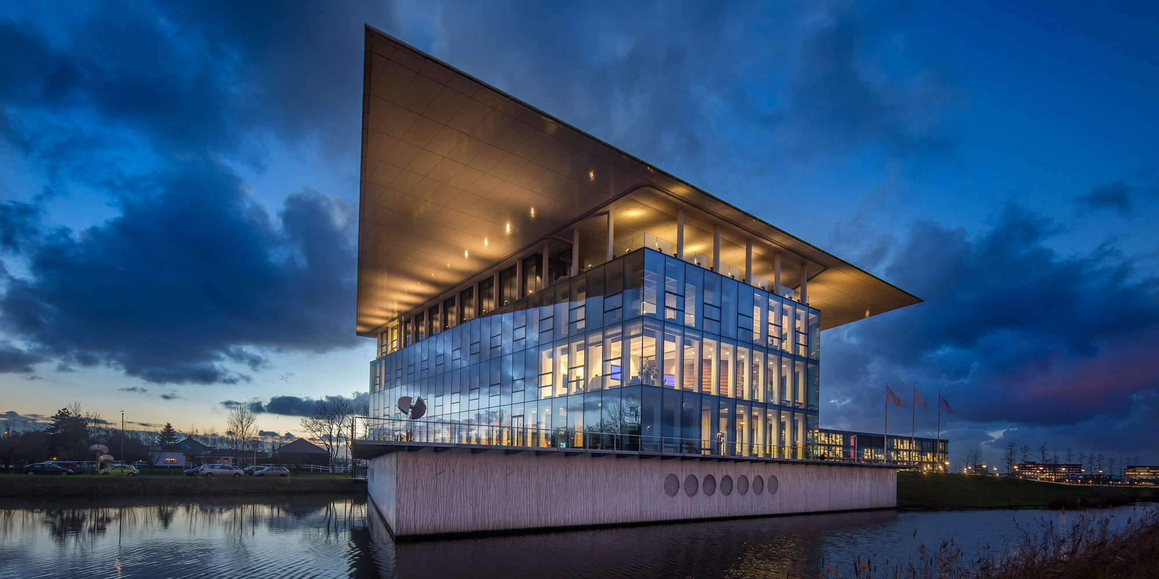
Smart Visie
Tobias Asserlaan 7
2662 SB Bergschenhoek
The Netherlands

+31 10 – 307 52 66
+31 10 – 307 52 66
contact@smart-visie.nl
www.smart-visie.nl

VAT: NL001422098B50
CoC: 27364759
Becon: 497786

ABN Amro Bank
NL25 ABNA 0587 5647 09
KNAB Bank
NL50 KNAB 0259 3688 57

/smartvisie
/company/smartvisie
/smartvisie
/smartvisie

